Kylah Green, Connor Ryan, Kevin Goodman
Dr. L
Software Engineering
8 September 2025
Milestone Three – Payroll
Description
Our project is to develop and implement a custom payroll system, that is tailored specifically to the needs of a construction company, Eichberg Construction. It will include time tracking, overtime, pay rate management for multiple roles, and integration with accounting systems. The stakeholder of our project is Jay Eichberg and John Doyle, both representatives of the construction company, Eichberg Construction. Our project is convincing to invest money into for the stakeholders due to all the benefits. It will enable reduced payroll errors, automate time-consuming processes that they may endure without our program, and the scalability we can give the company, because as the company grows our system will be able to adapt. The application will make the current user environment better by replacing the manual systems they may be using, such as spreadsheets and paper timesheets. It also will provide real-time tracking of hours and payroll costs per project, handle variable wages, bonuses, shift differentials, along with reducing the HR and accounting workload. The primary users of our program will be the payroll staff, human resources department, and project managers. The secondary users would be the employees, contractors, and company executives. Major capabilities of our program would be the time tracking, job costing, automatic payroll calculations, multiple pay rates, and much more.

Team Roles
- Requirements Analyst – Kevin Goodman
- Test Engineer – Connor Ryan
- Data Engineer – Kevin Goodman
- Project Manager – Kylah Green
- Deployment Engineer – Kylah Green
- Software Engineer – Connor Ryan

Requirements

REAM Requirements
The payroll system must support multiple user roles. Admins and normal users will have access to different information based on their roles. Admins will people to edit and add information for all users, while normal users will only be able to access their personal information in the form of timesheets and pay stubs. Employees with a user role will only be able to see information about themselves. Employees can log their hours and admins will be able to edit the timesheets. Any changes to the payroll will be logged for audit purposes. The system will be accessible through web browsers to provide remote access for employees.
- System will support multiple user roles
- System will allow users to log timesheets and hours
- Managers can review timesheets
- System will generate pay stubs for employees to access
- System will keep track of all payroll changes for audit purposes
- Accessible through web browsers (remote access)

Other Requirements
An algorithm will be implemented to automatically calculate how much each employee will earn in a paycheck based on their wages and timesheets. The system will be web-based and include a GUI where employees can view all information related to their individual pay. The user login will have input validation to protect the system from SQL injection. All employee information for timesheets, hours, and changes made will be logged.
- System will calculate wages automatically
- Web-based interface
- Users will have varying permissions based on roles
- Maintainability – easy to update pay rates and configurations
- Time tracking – employee hours will be logged
- Input Validation – protect from SQL injection

Prototypes
Initial screen prototypes (drawings, sketches, visual context of the explanations given)—
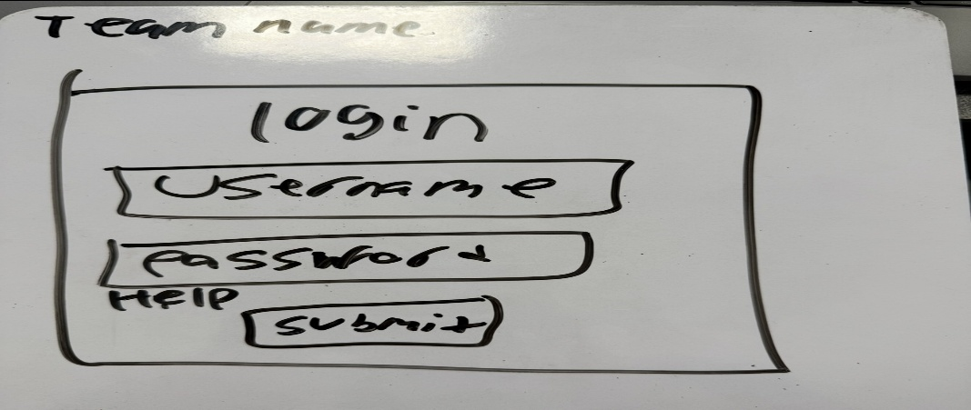
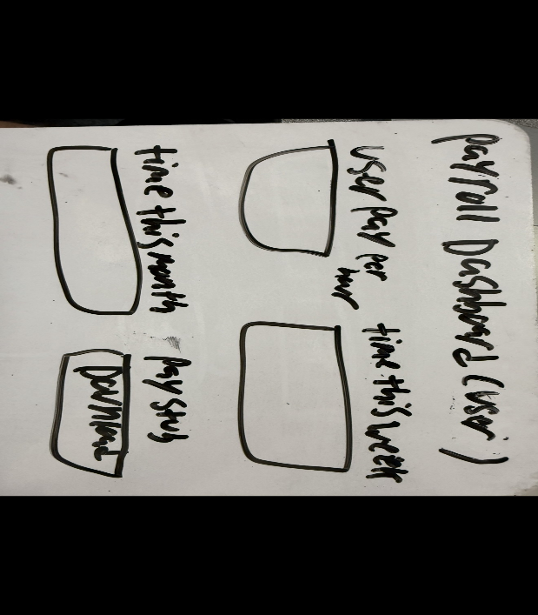
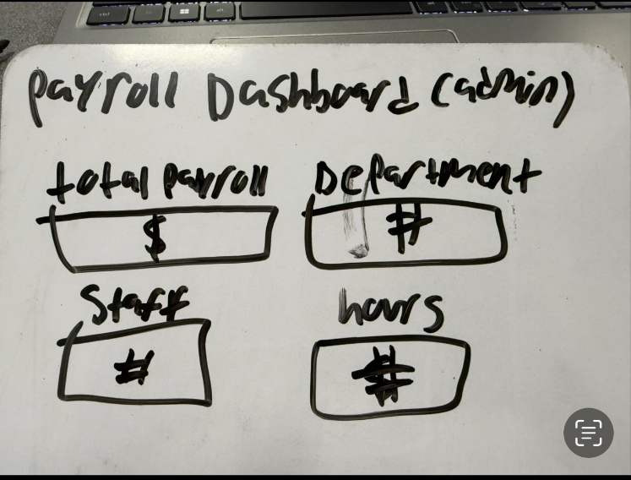
User Stories
Payroll Staff –
- Automatically calculating employee wages, overtime, and deductions
  - Process payroll quickly without manual errors
Human Resources –
- Reports of employee hours worked on different projects
  - Verify labor costs, correct billing information
  - Tracking employee hours by project
Project Manager –
- Approve timesheets
  - Review and approve employee timesheets from device
  - Process accurate payroll without delays
Employee –
- Log working hours and view payslips
  - Ability to confirm that they are being paid correctly

